Action D3
Monitoring wells
Photo Documentation

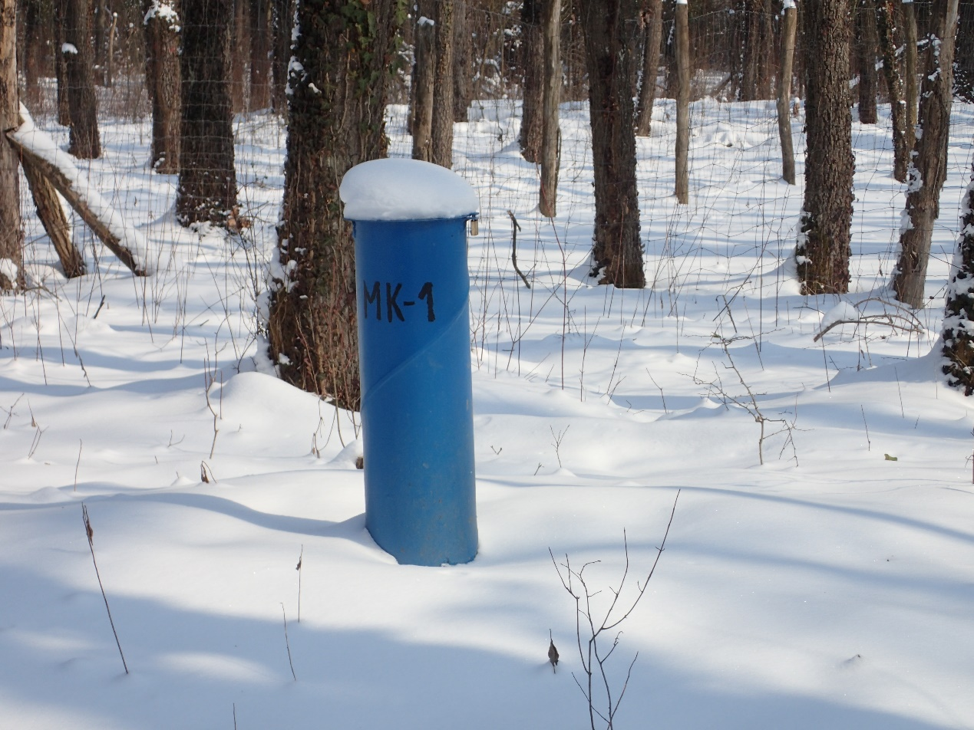
Monitoring well on high bank
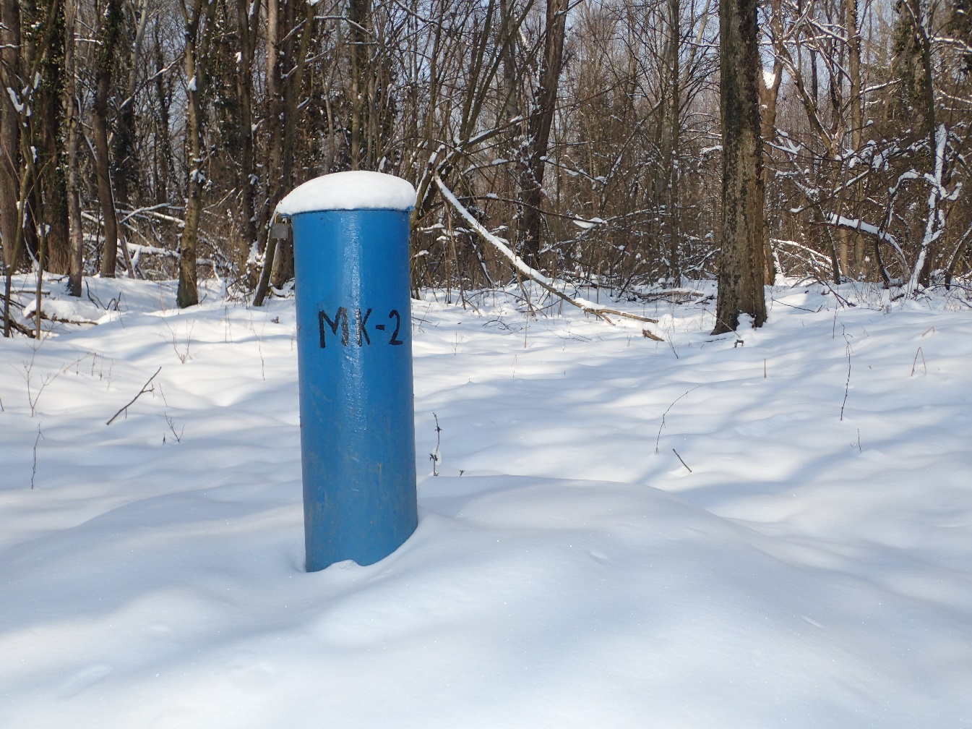
Monitoring well on floodplain

