Action D1
Water gauges
Photo Documentation
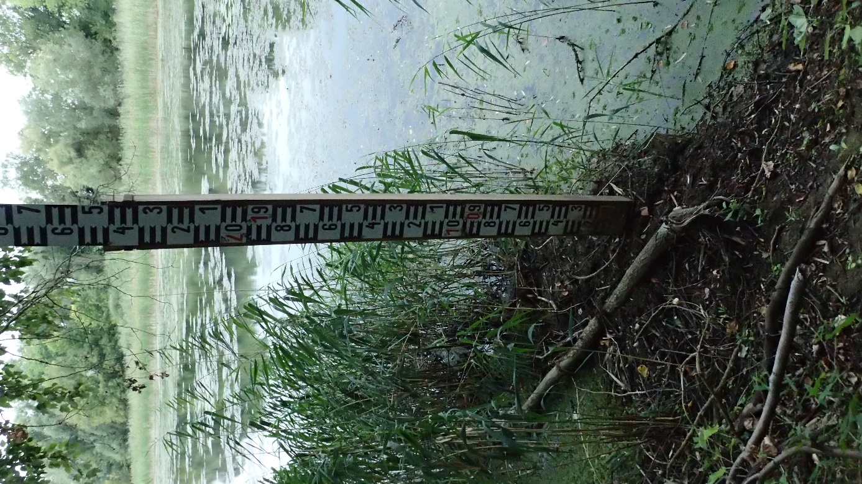
Gauge at “Csónakkikötő”
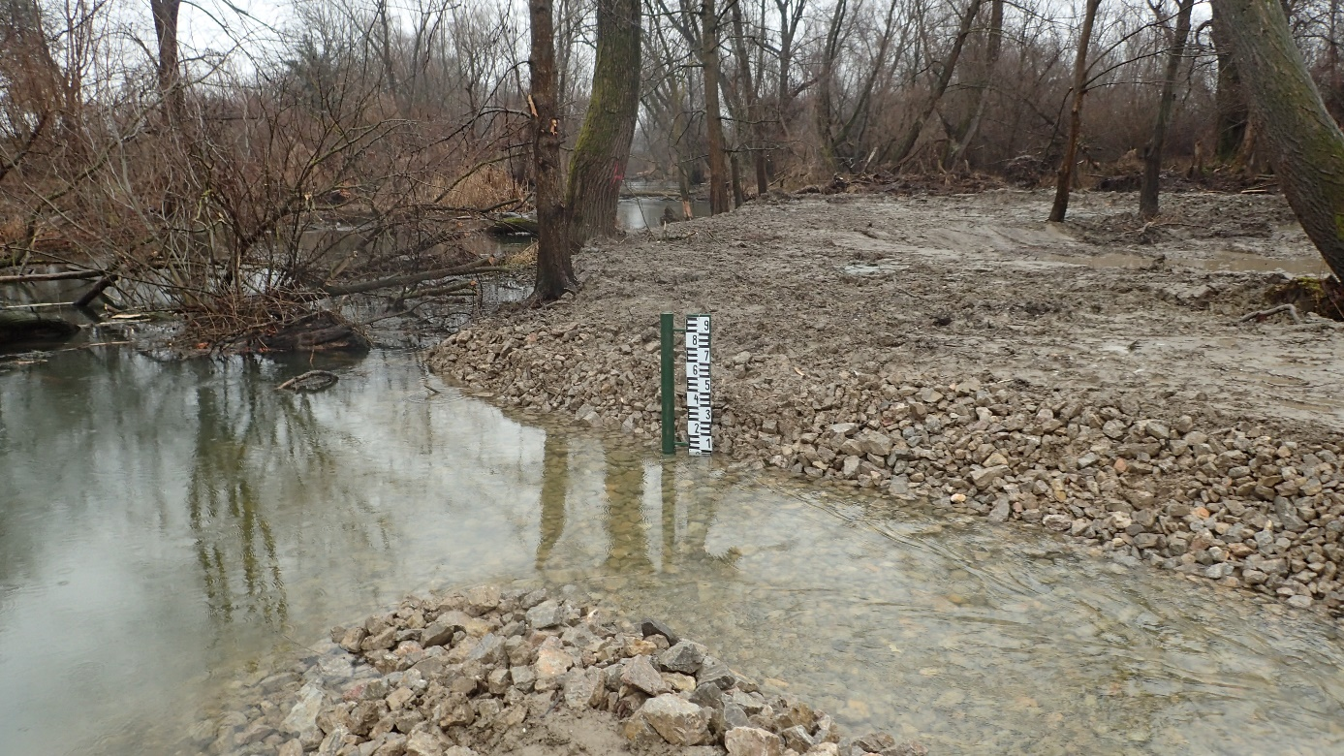
Gauge at the upstream section of fishpath
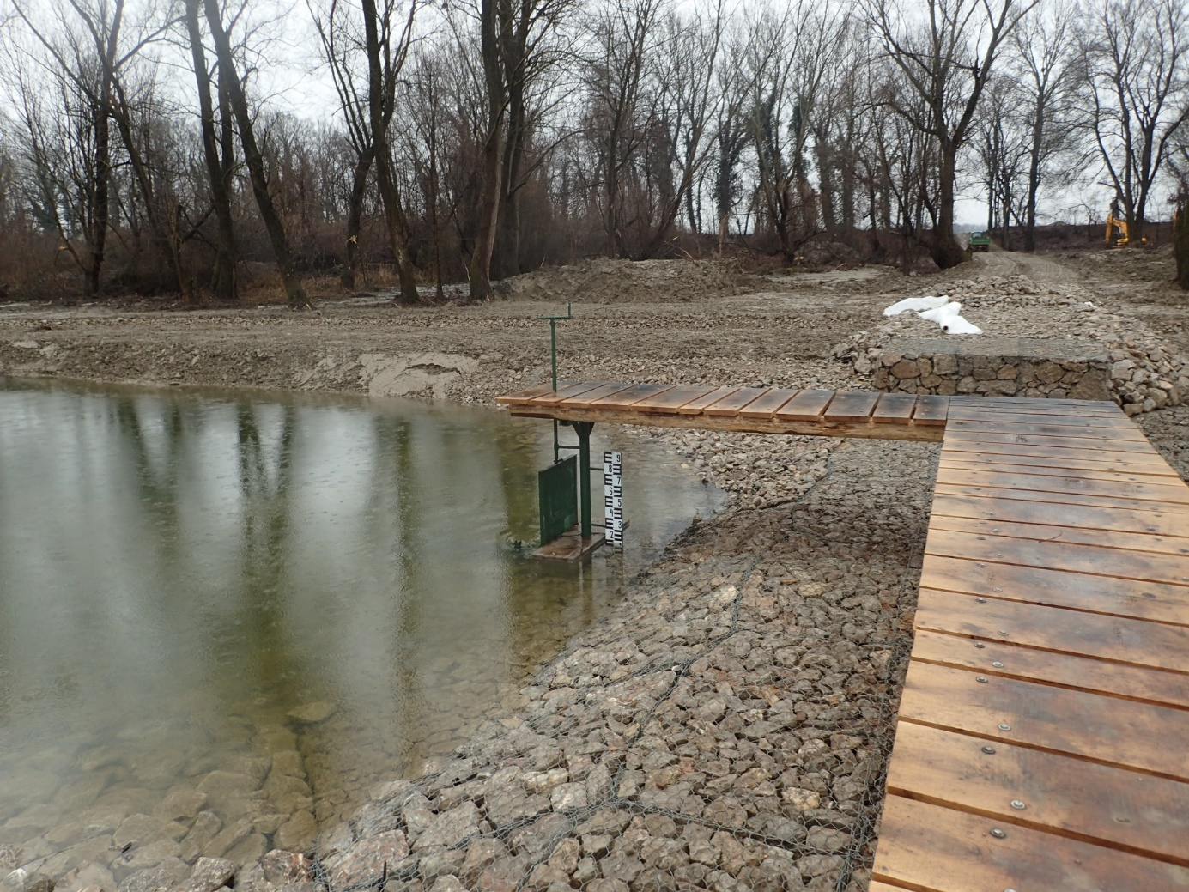
Gauge on bottomweir

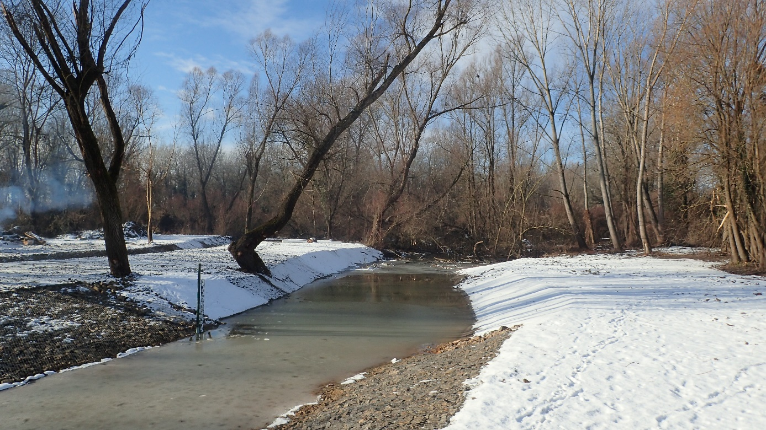
Gauge at downstream section of bottomweir

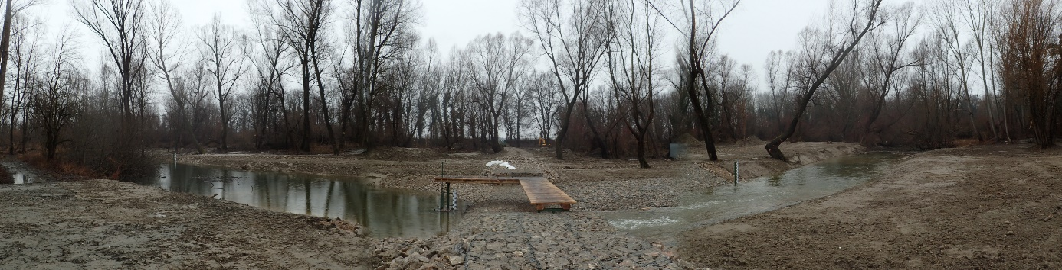
Location of three gauges at the bottomweir

